AMBIENT MONITORING REPORT
STATE 30-16 PAD
KERR-MCGEE OIL & GAS ONSHORE LP
Prepared For:
Kerr-McGee Oil & Gas Onshore LP
1099 18th St #1800
Denver, Colorado 80202
Prepared By:
Montrose Air Quality Services, LLC
990 W. 43rd Avenue
Denver, Colorado 80211
Document Number: 085AA-011278-RT-187
Reporting Period: September 27 through October 3, 2022
Report Date: October 4, 2022
Table of Contents
Project Overview 3
Summary 3
Project Scope 3
Contact Information 3
Sampling Locations for Monitoring 4
Summary of Down Time or Equipment Malfunction 5
Summary of Investigations and Response 5
On-Site IR Inspections 5
Discussion of Results 5
Summary of Results 7
Figure 1 – State 30-16HZ VOC Data 7
Figure 2 – State 30-16HZ Meteorological Data 8

Project Overview

Summary
Montrose Air Quality Services, LLC (Montrose) was contracted by Kerr-McGee Oil & Gas Onshore LP (Kerr-McGee) to conduct air monitoring at the State 30-16HZ Pad. This report covers the reporting period from September 27 through October 3, 2022. Facility monitoring commenced on September 10, 2021. Air Monitoring was conducted in accordance with applicable portions of the Kerr-McGee Air Monitoring Program that has been approved by Colorado Department Public Health and Environment (CDPHE). There were no readings from the continuous PID analyzers above the Investigation Levels.

Operation and maintenance of the PID analyzer followed procedures in the Quality Assurance Project Plan (QAPP) provided in the Kerr-McGee Air Monitoring Program. The analyzer used in this monitoring program was last calibrated on September 24, 2022 in accordance with the QAPP.

Project Scope
The PID analyzer used at the State 30-16HZ Pad (named “SPOD”) was manufactured by SENSIT. The sensor is solar powered and transmits data to the data platform via LTE cell technology. The data is 128-bit encrypted during transmission. One (1) sensor monitored for VOCs and meteorological parameters during the reporting period. All sampling was performed by Montrose.

Contact Information
The contact information for each of the principal parties is summarized in the tables below:

Chad Schlichtemeier |  | James Garrett
Oxy USA Inc. |  | Montrose Air Quality Services, LLC
1099 18th Street |  | 990 West 43rd Ave
Denver, CO 80202 |  | Denver, CO 80216
Phone: (720) 929-6867 |  | Phone: (303) 670-0530
E-mail: Chad_Schlichtemeier@Oxy.com |  | E-mail: Jagarrett@Montrose-Env.com

Sampling Locations for Monitoring
Sampling locations are labeled by ID on the map below. 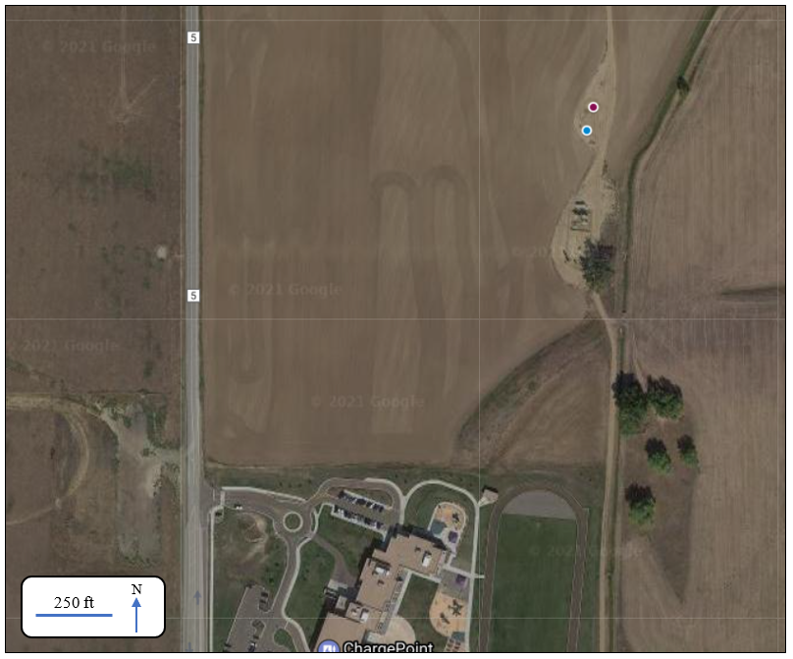

Location Tag | Description
 | State Pad Monitoring Wells
 | PID Analyzer

GPS coordinates of the locations are listed in the following table.
Location | GPS Coordinates | Monitoring Technology
State Pad Monitoring Wells | 40.05433, -105.01451 | NA
PID Analyzer | 40.05417, -105.01459 | PID Analyzer

Summary of Down Time or Equipment Malfunction
The PID Analyzer data recovery, which includes equipment malfunctions, during the reporting period are shown in the table below.
PID Analyzer Data Recovery | 100.00%

Summary of Investigations and Response
The Kerr-McGee Air Monitoring Program establishes Investigation Levels for the continuous monitors. If an Investigation Level is triggered, the monitoring program outlines an Investigation Level Response for each level.
During this reporting period, there were no continuous monitor readings that exceeded an Investigation Level.
Investigation Level 3: No notifications to Town of Erie within forty-eight (48) hours of responsive action(s) taken as a result of recorded values in excess of the Investigation Level 3 were required.

On-Site IR Inspections
Inspections are being conducted by the Oxy IR Team at the State Well 30-16 Pad using an optical gas imaging camera or more commonly referred to as an IR camera. The IR camera detects hydrocarbons, which includes methane, and volatile organic compound (VOC) emissions.

An IR inspection was conducted recently at the State Well 30-16 and no emissions were detected during the inspection.

Discussion of Results
The 15-minute block averages for the PID VOC results for the air sampling can be found in Figure 1.

Meteorological data, collected on the PID analyzer onsite, for the reporting period can be found in the Figure 2.

Prepared by:
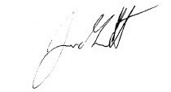
James Garrett

Summary of Results

Figure 1 – State 30-16HZ VOC Data

The graph below is shown for the PID Analyzer installed at the State 30-16HZ facility during the reporting period and is plotted with 15-minute averages.

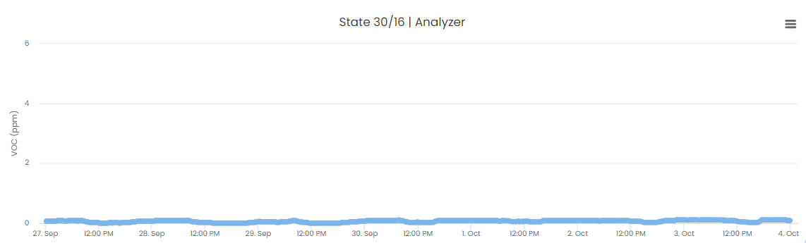

Figure 2 – State 30-16HZ Meteorological Data

The wind rose below is shown for State 30-16HZ facility and is plotted with 15-minute averages.

State 30-16HZ Wind Rose

